 **SHIKSHA(S.C.S.A.)**

Duration: 1hr Class-8

Max. Marks- 50 Scholarship Test (2024)

Name:____________________________________ Date-__________ **General Instructions:**

1. This Question Paper Consists of 4 Sections -

Maths (15 Marks), Science (15 Marks), English (10 Marks) and Hindi + SS (10 marks).

2. All Questions are Compulsory.

3. Read all the Questions and Instructions Carefully.

4. Any form of cheating or malpractice will result in immediate confiscation of answer sheet and deduction in marks. _______________________________________________

**MATHS**

1.) The product of two rational number is always _________ (1)

2.) solve the equation: 3x=2x+18 (1)

3.) In the parallelogram RING , if angle R=70 degree then find all the other angles (1)

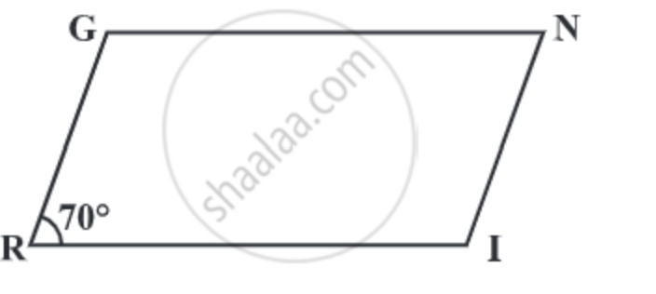

4.) a) what is the probability of getting an odd number when a die is thrown. (1)

b) find the square root of : i)2.56 ii)51.84 (2)

5.) find the factor of (3m^2+9m+6) (2)

6.) simplify:-

i)(3^-7÷3^-10)×3^-5. (2)

ii)(1/2)^-5. (2)

7.) Find the area. (3)

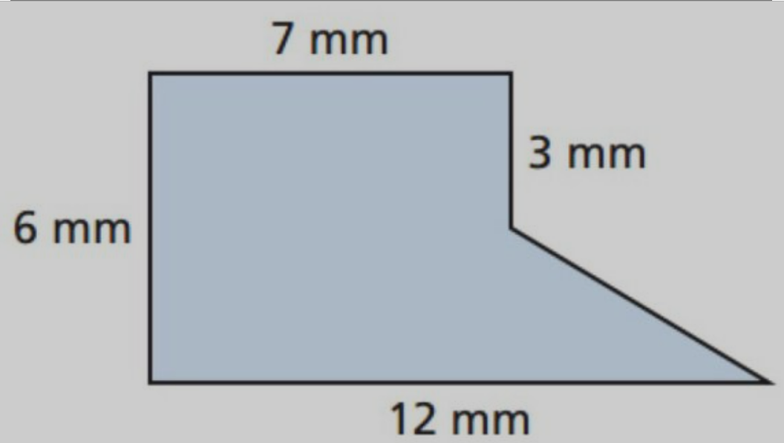

**SCIENCE**

**1.What is drag? (1)**

**2.What are the units of force and pressure? (1)**

**3.What do you mean by refining? (1)**

**4.Which mirror is used as rear view mirror in vehicles?(1)**

**5.What is pasteurization?(2)**

**6.Write characteristics of plane mirror.(2)**

**7.What are the consequences of deforestation?(2)**

**8.What is irrigation? Explain the modern and traditional methods of irrigation.(5)**

**ENGLISH**

**Section A: Reading Comprehension (10 marks)**

Read the passage and answer the questions:

Summer vacation had finally arrived, and Sarah was excited to spend her days at the beach. She packed her beach bag with sunscreen, a towel, and her favorite book. As she reached the sandy shore, Sarah noticed the sparkling waves crashing against the rocks. She quickly found a spot near the water and laid down her towel. The warm sun beamed down, and Sarah felt a sense of peace wash over her.

1.What did Sarah pack in her beach bag?(2)

____________________________________________________________________________________________ ________________

2.Where did Sarah lay down her towel?(2)

____________________________________________________________________________________________ ________________

3.How did Sarah feel at the beach?(2)

____________________________________________________________________________________________ ________________

4.Choose the correct option to complete each sentence:

i. I ________ my homework yesterday. (1)

a) finished b) finish c) finishing

ii. She ________ her grandmother every Sunday.(1)

a) visit b) visits c) visiting

5. Write a paragraph on 'My Dream '.(5)

6. Write a sick leave application to your school principal.(5)

**SOCIAL STUDIES [1*5=5]**

1.Who was the first governor general of India?

2.What do you mean by renewable resources?

3.What is constitution?

4.How many states and union Territories in India?

5.What is the capital of Haryana?

**HINDI**

प्रश्न 1.)संधि विच्छेद किजिये | (2)

क) भोजनालय

ख) इत्यादि

प्रश्न 2.) मेरे प्रिय मित्र पर एक लेख लिखें | (3)